

**Module Code & Module Title**

**CS6P05NI Final Year Project**

**Assessment Weightage & Type**

**5% FYP Proposal**

**Semester** **2023 Autumn**

**PROJECT TITLE:**

**VendorInsight: Advanced Vendor-Centric Analytics and AI-Driven Recommendations**

**Student Name: Nishant Parajuli**

**London Met ID: 22015718**

**College ID: np01cp4s220009**

**Internal Supervisor: Rubin Thapa**

**External Supervisor: Subash Basnet**

**Assignment Due Date: 29th November 2023**

**Assignment Submission Date: 28th November 2023**

**Word Count (Where Required): 2046**

*I confirm that I understand my coursework needs to be submitted online via Google Classroom under the relevant module page before the deadline in order for my assignment to be accepted and marked. I am fully aware that late submissions will be treated as non-submission and a mark of zero will be awarded.*

**Table of Contents**

1. Introduction 1

1.1. Problem Scenario 1

1.2. Project as a Solution 3

2. Aims and Objective 4

3. Expected Outcomes and deliverables: 5

4. Project risks, threats, and contingency plans: 7

5. Software Development Methodology 8

5.1. Selected Methodology: 9

6. Resource Requirements: 12

7. Work Breakdown Structure 13

8. Milestones 14

9. Gantt Chart 15

10. Conclusion 16

References 17

**Table of figures:**

Figure 1: The financial Inclusion factors in Nepal (DATAREPORTAL, 2023) 2

Figure 2: Scrum Methodology (Covetus, 2019) 8

Figure 3: Work Breakdown Structure 13

Figure 4: Milestone Chart 14

Figure 5: Gantt Chart 15

**Table of tables:**

Table 1: Project risks, threats, and contingency plans 7

**VendorInsight: Advanced Vendor-Centric Analytics and AI-Driven Recommendations**

# Introduction

This project is focused on the development of a sophisticated web application targeted at e-commerce platforms which leverages artificial intelligence to enhance the vendor and customer experience. At the core of this application, it is designed to pioneer advanced analytics in sales optimization and to pioneer personalized recommendation systems for e-commerce sales. The intent of the project is to construct a multi-vendor e-commerce platform enriched by AI-driven capabilities, most notably a recommendation engine using sentiment analysis of customer reviews and predictive analytics which will help to boost vendor sales optimization.

## Problem Scenario

As Nepal navigates its e-commerce evolution, statistical insights reveal a market ripe for innovation. With a predicted revenue of US$603.1 million in 2023 and a compound annual growth rate of 9.1%, the e-commerce sector in Nepal shows substantial potential for expansion (ecommerceDB, 2023)​​. There is a significant potential for the growth of ecommerce in Nepal as there are still significant portions of the population underserved by digital financial services as only around 18.8% of the population have made a digital payment in the past year (DATAREPORTAL, 2023). However, this growth presents challenges that this project aims to address:

1. Vendors are often without the necessary tools for deep analytics and precise sales forecasts, leading to suboptimal inventory and pricing decisions.
2. Current recommendation systems may not effectively harness customer feedback and sentiment to generate personalized suggestions, possibly leading to lower engagement and satisfaction levels among shoppers.
3. Traditional e-commerce platforms may not offer seamless integration and management solutions for multiple vendors, leading to operational inefficiencies and a lack of competitive variety for customers.

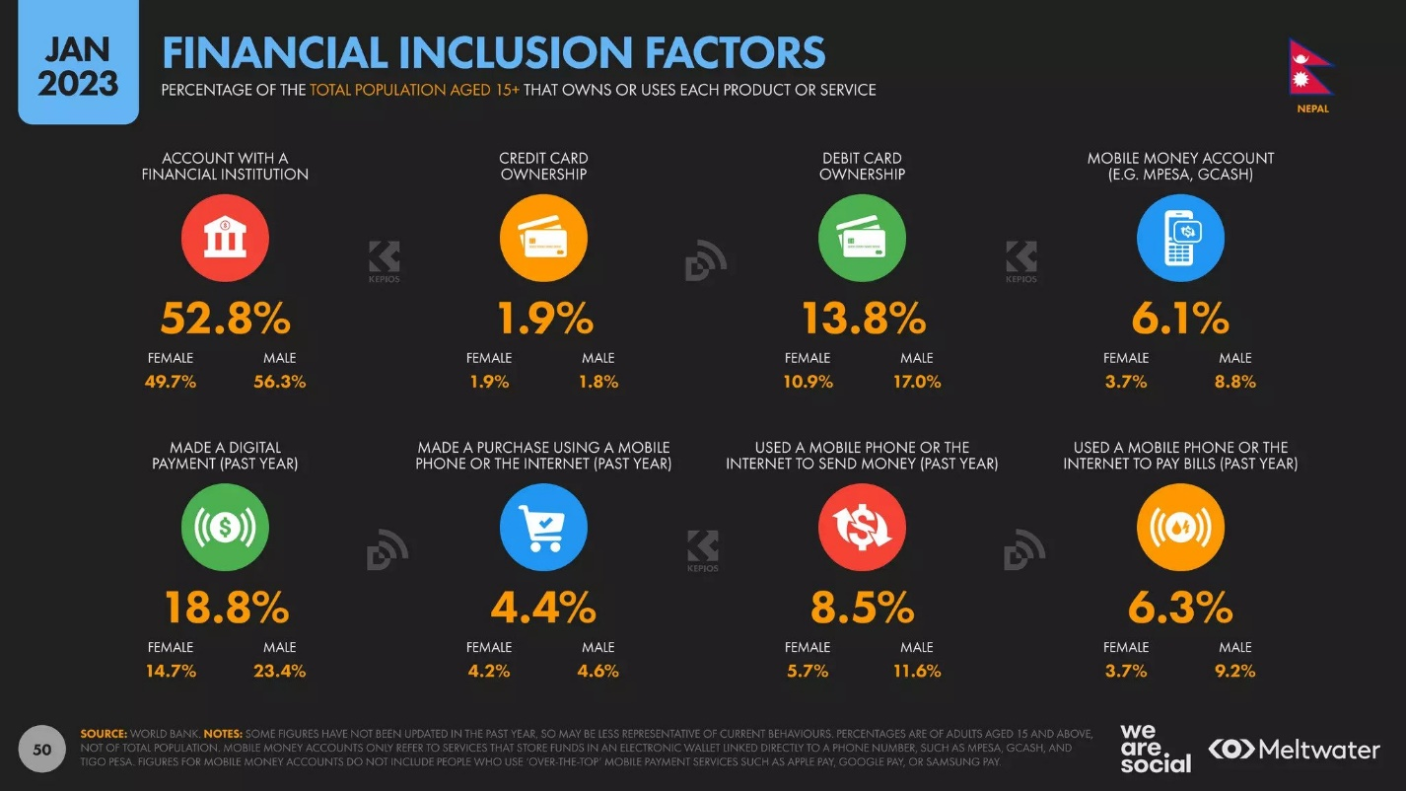

Figure : The financial Inclusion factors in Nepal (DATAREPORTAL, 2023)

## Project as a Solution

This project aims to develop an advanced e-commerce platform equipped with predictive analytics capabilities to assist vendors in optimizing their sales strategies while enhancing the shopping experience for customers in Nepal. The key features of this solution include:

1. Predictive Analytics for Vendor Sales:

* Sales Forecasting: Employing machine learning algorithms to analyse historical sales data along with market trends to provide accurate sales forecasts for vendors.
* Inventory Optimization: Utilizing predictive analytics to suggest optimal inventory levels, thus reducing carrying costs and the risk of stockouts.

1. Enhanced Recommendation Systems:

* Personalized Recommendations: Leveraging customer data, purchase history, and real-time behaviour to generate personalized product recommendations, enhancing customer satisfaction, and boosting sales.
* Sentiment Analysis: Analysing customer reviews and feedback to identify product trends and customer preferences, further refining the recommendation engine.

1. Multi-Vendor Platform Management:

* Vendor Dashboard: Providing an intuitive dashboard for vendors to manage their store, view analytics, and adjust pricing and inventory.
* Seamless Integration: Offering seamless integration solutions for multiple vendors to easily onboard and manage their products on the platform.

# Aims and Objective

The primary aim of this project is to create a vendor focused analytics webapp for ecommerce platforms which includes features such as advanced recommendation which implements sentiment analysis as a feature for the recommendation model.

The Objectives of the project are:

* Design and develop a predictive analytics tool for accurate sales forecasting, inventory optimization, and dynamic pricing.
* Implement an enhanced recommendation system utilizing personalized recommendations and sentiment analysis to boost customer engagement.
* Create a multi-vendor platform management system that allows seamless integration, management, and competitive variety for vendors.
* Evaluate the effectiveness of the predictive analytics and recommendation systems through real-time testing and feedback collection.
* Ensure scalability and security of the platform to handle increasing data volumes and ensure data privacy.
* Research Django Framework and integration of various AI models in the backend framework
* Gain extensive knowledge on analytics on a business scale for various businesses.

# Expected Outcomes and deliverables:

Upon the completion of the project, “VendorInsight” would have completed the objectives outlined for the project. This includes the deployment of a user-friendly e-commerce platform with robust analytics for vendors, an AI-powered recommendation engine for personalized shopping experiences, and a streamlined interface for multi-vendor management. A well-designed backend application developed with python Django framework and Final year project report will be provided upon the completion of the project. The deliverables of the project are outlined below:

1. **User Registration and Authentication:**

* Users should be able to register for an account.
* Users should be able to log in and out of their account.

1. **User Profile:**

* Users should have profiles that display their information.
* Users should be able to edit and update their information.

1. **Vendor Registration:**

* Users that want to register as a vendor should be able to register as one.
* Users Registered as a vendor should have access to vendor specific features.

1. **Item Listing:**

* Vendors should be able to list their products with detailed descriptions, images, and pricing.
* Listings should have categories and tags to help users find products easily.

1. **Inventory Management:**

* Vendors should be able to manage their stock levels in real-time.
* Automated alerts for low stock and suggestions for restocking based on predictive analytics.

1. **Sales Analytics Dashboard:**

* Real-time sales data visualization for vendors to monitor performance.
* Customizable reports and metrics to understand sales trends and make data-driven decisions.

1. **Customer Review and Sentiment Analysis:**

* Customers can leave reviews and ratings for products.
* Sentiment analysis tools to gauge customer feedback and inform product recommendations.

1. **Personalized Recommendations:**

* AI-driven suggestions for customers based on their browsing history and preferences.
* Dynamic recommendation algorithms that update based on real-time interactions.

1. **Product Management Dashboard:**

* A dashboard that allows you to view all your products and adjust them on the fly.
* Features allowing vendors to create promotions and discounts for their products.

# Project risks, threats, and contingency plans:

Some risks and threats are expected during the development of this system. Some of which are as follows:

|  |  |  |  |
| --- | --- | --- | --- |
| **Risk** | **Threat** | **Contingency Plan** | **Threat Severity** |
| Technical Complexity | Development of predictive analytics and recommendation systems pose technical challenges. | Engage in thorough technical planning and consider seeking external expertise or partnerships. | High |
| Data Accuracy and Availability | Predictive models' efficacy relies on the accuracy and availability of data. | Establish robust data validation procedures and develop partnerships to ensure reliable data sourcing. | High |
| Integration Issues | Issues may arise during the integration of different software components or third-party services. | Use well-documented integration standards, perform extensive testing, and have a dedicated integration team. | High |
| Security Vulnerabilities | Potential exposure to data breaches or other cyber-attacks due to security loopholes. | Conduct thorough security assessments, follow best security practices, and maintain a patch management strategy. | Low |
| User Acceptance | Users might not accept or adapt to the new platform, especially if they are accustomed to other platforms. | Conduct market research to understand user preferences and build features that meet their needs. | Low |

Table : Project risks, threats, and contingency plans

# Software Development Methodology

Software development methodology is a process by which developers design, implement and test new computer programs. Following a methodology benefits developers because these processes lay out a structured sequence of steps that guide professionals through each stage of development (Indeed Editorial Team, 2023).

It includes a set of tasks, practices, frameworks, and processes used by stakeholders to manage and improve the creation of software. There are several methodologies, each with its own approach, principles, and practices. 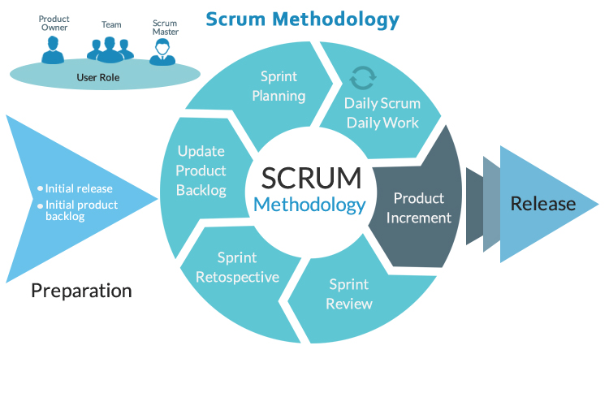

Figure : Scrum Methodology (Covetus, 2019)

## Selected Methodology:

* **Scrum Methodology**

The methodology that was chosen for the system is Scrum Methodology as it will allow me to rapidly make changes in areas that requires changes fast. The key focus of Scrum methodology is effective prioritization where it is easier to assign different priorities to different components of the project which will allow me to focus on the resources of the most important elements of the project.

The methodology has 5 stages which are:

1. **Initiation**

The initiation phase of a Scrum framework is the period in which you create a vision for your project. This includes important identification points, such as noting who the stakeholders are for the project and assigning the role of Scrum Master to yourself. During initiation, you determine the confines of your epic, which is the overall project your team is working toward.

1. **Planning and estimation**

During this phase, you create plans for a sprint, which is a short, time-boxed period that can help your team collaborate more effectively. As your team completes each sprint, you can then combine them later to complete all necessary elements in the project backlog. You can also use this time to create estimates about your expectations for the sprint, including what your team will deliver and when.

1. **Implementation**

The implementation phase is when you implement the sprint as planned. During this phase, you maintain an updated backlog, removing items as staff complete them and assigning out new items from the backlog as needed. You conduct daily standup meetings to provide project updates and review the work plans or concerns.

1. **Reviewing and Retrospect**

The reviewing phase focuses on assessing whether or not the Scrum team has met the Scrum goal. The Scrum Master leads the sprint review meeting and establishes what documentation should be produced. The team then looks at their work and decides if they have completed all of the tasks necessary to meet the sprint backlog.

1. **Releasing**

The last phase is the release phase, in which you deliver any final products to stakeholders, such as bringing a product to market or providing a client with the developed technology. After releasing the product, consider organizing a project retrospective meeting with your team to analyze the performance of each individual sprint and to discuss the overall performance of the project.

Scrum methodology was chosen as a suitable methodology for the project for the following advantages:

* Scrum is highly adaptable to changes, which is essential for individual projects where requirements may evolve over time. It allows for rapid adjustments and iterative development, which is ideal for responding to feedback or new insights.
* With its sprint-based structure, Scrum facilitates quicker releases of workable features or sections of the project. This means you can evaluate and refine the project continually, ensuring a better end product.
* Scrum's daily stand-ups and regular sprints provide clear visibility into the project's progress and any obstacles encountered. This offers better control over the timeline and deliverables, even for an individual.
* Since Scrum emphasizes prioritization and iterative development, it can be more cost-effective. It reduces the likelihood of extensive rework by catching issues early, and the iterative nature allows for adjusting the scope to align with available resources.

# Resource Requirements:

For the successful completion of this project, the requirements of the projects are:

* **Backend Development:**
  + Python: Leveraged for its powerful libraries like Django for building the backend services.
* **Frontend Development:**
  + JavaScript: Essential for creating interactive and dynamic user interfaces.
  + HTML5, CSS3 and Bootstrap: For structuring and styling the web pages.
* **Frameworks and Libraries:**
  + Django: Robust frameworks for building scalable and secure web applications.
  + PyTorch: For developing the machine learning models necessary for predictive analytics and recommendations.
  + Pandas, NumPy, and Scikit-learn: Essential libraries for data manipulation and analysis.
* **Database Systems:**
  + PostgreSQL: Relational database systems for managing structured data efficiently.
  + MongoDB: A NoSQL database for handling unstructured or semi-structured data.
* **Version Control System:**
  + Git: For tracking changes in the source code during software development.
* **Development Tools:**
  + Integrated Development Environments (IDEs) like PyCharm, Visual Studio Code, or JetBrains IntelliJ IDEA.

# A diagram of a company Description automatically generatedWork Breakdown Structure

Figure : Work Breakdown Structure

# Milestones

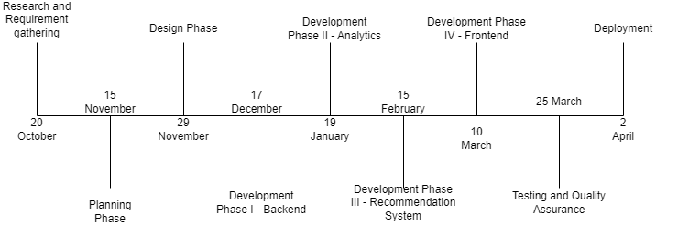

Figure : Milestone Chart

# Gantt Chart

Figure : Gantt Chart

# Conclusion

In conclusion, the "VendorInsight" project aims to revolutionize the e-commerce landscape of Nepal by introducing a sophisticated multi-vendor platform powered by artificial intelligence. By leveraging predictive analytics for vendor sales and implementing an AI-driven recommendation system, the project seeks to optimize vendor operations and enhance the customer shopping experience. The comprehensive solution will address existing gaps in the market by empowering vendors with advanced sales forecasting, inventory management, and personalized customer interactions. With a focus on scalability and security, the platform is set to navigate the challenges of Nepal's burgeoning e-commerce sector. The adherence to the Scrum methodology ensures a flexible and iterative approach to development, enabling the project to adapt to changing requirements and feedback efficiently. Ultimately, "VendorInsight" is poised to deliver a cutting-edge e-commerce platform that meets the growing demands of vendors and consumers alike, fostering a dynamic and competitive digital marketplace.

# References

Covetus. (2019, April 18). *Agile Scrum Methodology for Project Management*. Retrieved from Covetus: https://www.covetus.com/blog/scrum-methodology-agility-with-endurance

DATAREPORTAL. (2023). *DIGITAL 2023: NEPAL.* Singapore: DATAREPORTAL.

ecommerceDB. (2023, October 1). *eCommerce market in Nepal.* Retrieved from ecommerceDB: https://ecommercedb.com/markets/np/all

Indeed Editorial Team. (2023, August 21). *What Is a Software Development Methodology?* Retrieved from Indeed: https://au.indeed.com/career-advice/career-development/software-development-methodology

Inflectra. (2023, November). *What is Agile Scrum Methodology?* Retrieved from Inflectra: https://www.inflectra.com/Methodologies/Scrum.aspx

Kagan, J. (2023, September 28). *What Is a Milestone Chart and Why Is it Important?* Retrieved from nifty: https://niftypm.com/blog/what-is-a-milestone-chart/

ProjectManger. (2023, November 26). *What Is a Work Breakdown Structure (WBS)?* Retrieved from ProjectManger: https://www.projectmanager.com/guides/work-breakdown-structure

Rzeznik, P. (2023, March 9). *Agile Software Development: Extreme Programming (XP) Explained*. Retrieved from nearshore-it: https://www.nearshore-it.eu/articles/project-management-leadership/extreme-programming-complete-guide/

Timilsina, P. (2023, January 31). *E-commerce in Nepal: Does it have a hopeful future?* Retrieved from OnlineKhabar: https://english.onlinekhabar.com/e-commerce-in-nepal-future.html

Venema, M. (2023, November 16). *What Is Extreme Programming (XP)? It's Values, Principles, And Practices*. Retrieved from nimblework: https://www.nimblework.com/agile/extreme-programming-xp/